Subject: New Health Benefit: Livongo for Diabetes is Now Available at No Cost to You

All Employees/Retirees enrolled in the United Health Care Plans,

We are excited to announce Livongo for Diabetes, a new health benefit being offered at no cost to you. The Livongo for Diabetes Program makes living with diabetes easier by providing you with a connected meter, unlimited strips, and coaching.

Eligible Members: The program is offered at no cost to members and covered dependents with diabetes and coverage through the UHC Non-Medicare HMO and PPO plans at Capistrano Unified School District.
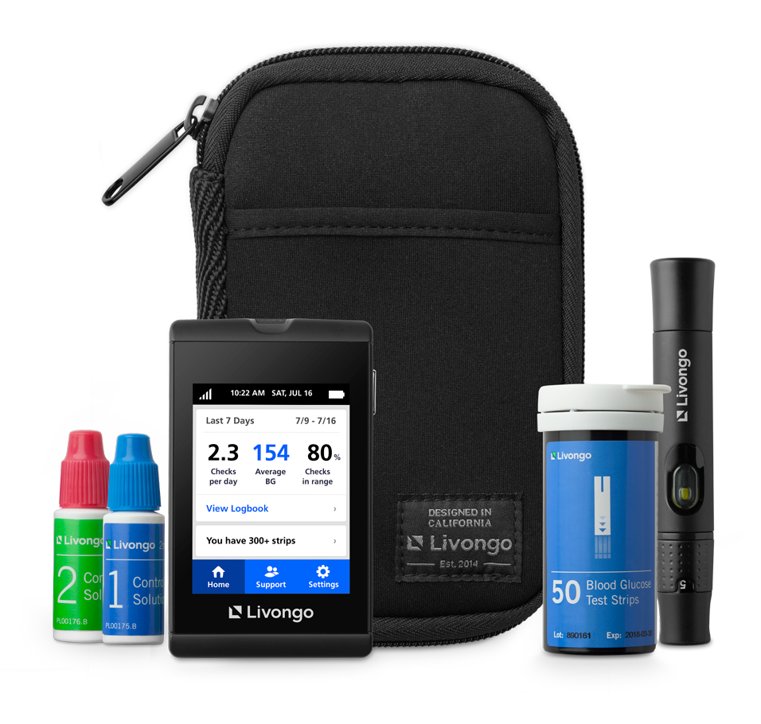
Here are some of the benefits of this program:

- More Than a Standard Meter: The Livongo meter is connected and provides real-time tips and automatically uploads your blood glucose readings, making log books a thing of the past.

- Unlimited Strips at No Cost to You: Get as many strips and lancets as you need with no hidden costs. When you are about to run out, Livongo ships more supplies, right to your door.

- Coaching Anytime and Anywhere: The Livongo coaches are Certified Diabetes Educators who are available anytime via phone, text, and our mobile app to give you guidance on your nutrition and lifestyle questions.

To Learn More or Join: join.livongo.com/CSVEBA/now

We are continually looking for ways to add programs that will enhance our benefits offering and help maintain and improve your health and the health of your family members. If you have any questions about this program, please visit the Livongo website or call Livongo Member Support at (800) 945-4355 and mention registration code CSVEBA.

El programa Livongo está disponible en Español: Cuando se registre, usted seteará el idioma de preferencia y luego el medidor y el programa estarán en Español.

Para registrarse en Español, por favor llame al (800) 945-4355 o visite bienvenido.livongo.com/CSVEBA.

Thanks,
-Capistrano Unified School District Insurance Department

PM01884.B

